These few quick notes will help you find your bearing and know what to do when you join the online summer party. The software will be set up with one main room, and several themed rooms for discussion of particular subjects. You may wander between rooms at will.

Below is the main screen. Click the microphone at the bottom to toggle your mic on and off, and the same for the camera. The pane above these icons will display the video (for those sharing their video). The pane to the right will contain the chat sessions, by default, but if you look at the bottom, there are several other tabs that can be displayed here as well. In the below snapshot, I am the only attendee, and I have not yet turned on video or audio. You can see in the Chat tab below and to the right, that there are three chat sessions I can join, one for Everyone, one for just Moderators (you will not see this one unless you are a Moderator) and then a chat session for the Cryonics & Society breakout room, which happens to be the room I am currently in.

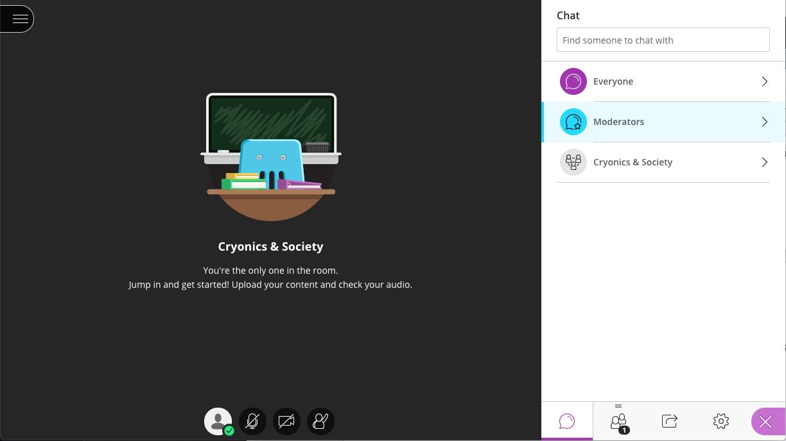

Here is a shot from the Collaborate promotional materials showing a meeting in session with several attendees sharing video:

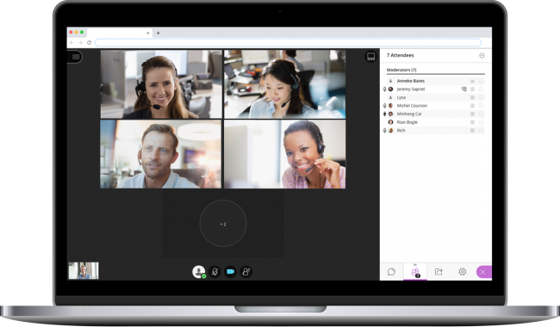

Note that the attendees tab is now showing on the right, listing all the attendees in the room I am in.

For our party, the Attendees tab will look something like this:

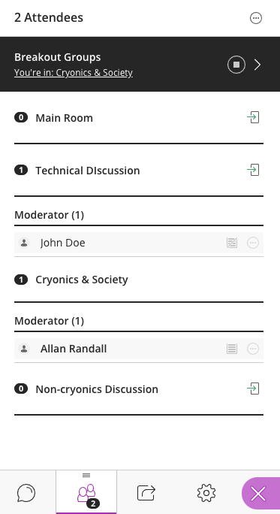
Note that there are two attendees right now, but each is in a different room. No one is in the Non-cryonics discussion room, or the Main room (which is the room you are in when you first join). To join a room, just click on the little door with an arrow next to the name of the room:
Note that there will be several pre-set breakout rooms with discussion themes, but there will also be plenty of other un-named rooms that you are free to use. If you and any other participants in an un-named room wish to give it a name, please ask a Moderator to do it for you.

The third tab is for sharing. This will normally be empty unless you are a Moderator or Presenter, in which case you will have several options:

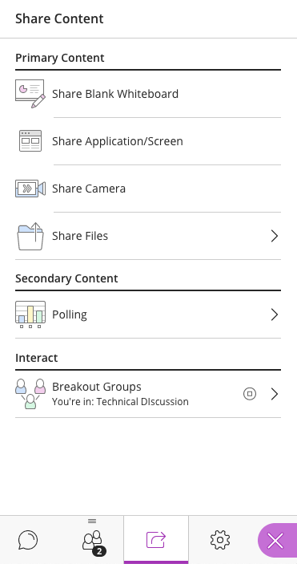

Note that if you wish to scribble, you may share a whiteboard. You may also share your screen or the window of any of your running applications. If you wish to share a Powerpoint or Word document, you can share the app window, or you can choose Share Files to share the file directly.

If you are a regular Participant, and not a Presenter or Moderator, then you will not have access to any of these Sharing features. However, if you have something you wish to share, you may ask a Moderator to make you a Presenter.

The final tab is for Settings, which allows you to change various options such as Speaker Volume, and set up your camera and mic should they need it. If sound and audio are not working properly, you should go here to see if you can fix it.

Finally, when you are done, you may leave the party by clicking on the main menu icon in the top left of the main window pane:

This will bring up several option, including a Leave session button on the bottom, which looks just like the Enter room buttons, except the arrow is pointing out of the room to exit:

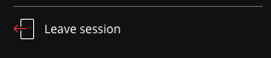

If you cannot figure something out, send Ilir, Ben, Christine or myself (Allan) a chat message and we will try to help you out. See you there!

